HIGH LEVEL DESIGN

**Table of contents**

| 1. | Introduction__________________________________________________________ | 03 |
| --- | --- | --- |
|  | 1.1 Purpose __________________________________________________________ | 03 |
|  | 1.2 Reference_________________________________________________________ | 03 |
| 2. | Architecture__________________________________________________________ | 03 |
|  | 2.1 Class diagram______________________________________________________ | 03 |
|  | 2.2 Use case diagram___________________________________________________ | 04 |
|  | 2.3 ER diagram________________________________________________________ | 06 |
| 3. | Revision history of the work product ______________________________________ | 07 |

1. **Introduction:**

Blood banking management system is an application-based project which is developed using C++ programming language and its concepts including file handling and data structures.

* 1. **Purpose:**

The purpose of this project is to provide is to assist the information of blood bag during its handling in the blood bank. This system is designed tostore, process, retrieve and analyse information concerned with the administrative and inventory management within a blood bank. It aims to maintain all the information related to the blood donors, different blood groups available in the blood bank and help them manage in a better way.

* 1. **Reference:**

[**http://cppreference.com/**](http://cppreference.com/)

1. **Architecture:**
   1. **Class diagram:**

A class diagram is an illustration of the relationships and source code dependencies among classes.

In the below class diagram it is clearly shown that,

this project consist of 5 main entities for which 5 main classes has been created as follows:

1. Login
2. Admin
3. Customer
4. Donor
5. Hospital

Remaining classes are created to reduce complexity of code. In this application there are 4 roles namely Admin, Customer, Donor, Hospital. Admin is supervising the customer, donor and hospital. A person class has been created which contains all the person attributes and since donor and customer are persons, they have ‘is-a’ relationship between them and hence these two classes are inherited the person class. Order and stock have a ‘has-a’ relationship with the customer, donor and hospital modules. Person class has containment relation with date class.

|  |
| --- |

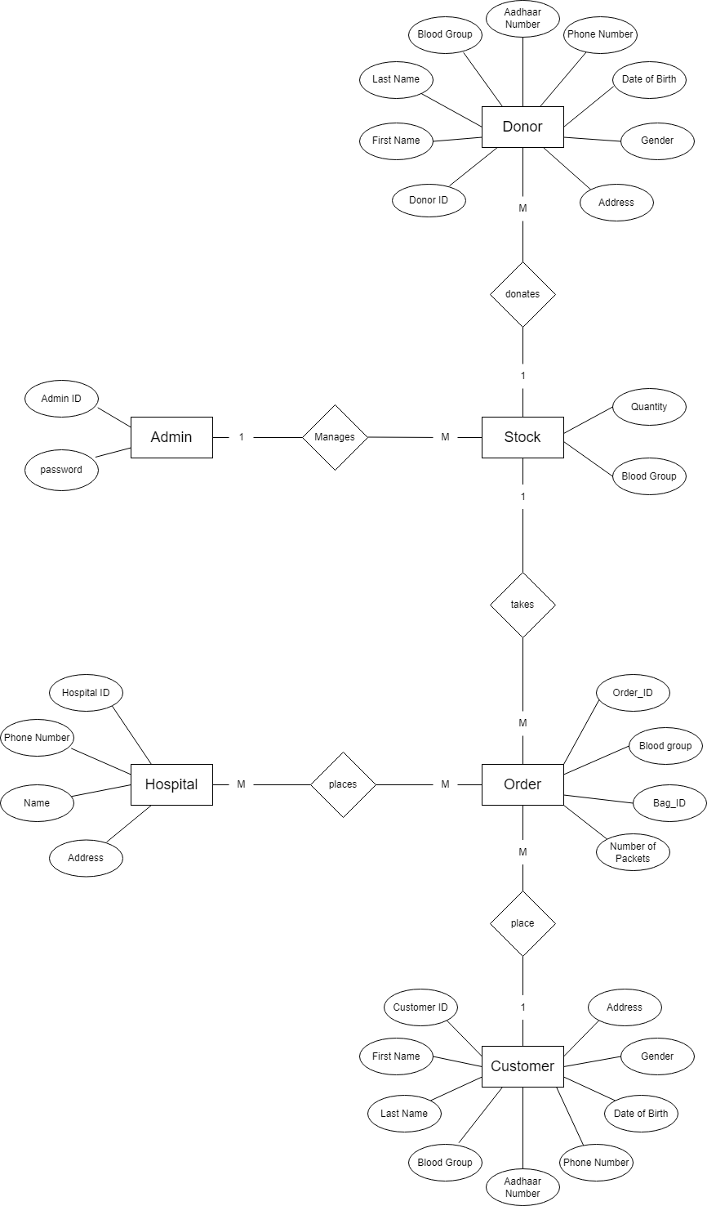

* 1. **Use case diagram:**

Use-case diagrams illustrate and define the context and requirements of a system. Use-case diagram: a high level overview of the relationship between use cases, actors and systems. The use cases and actors in use-case diagrams describe what the system does and how the actors use it, but now how the system operates internally.

The below diagram is on the right side and the user is on the left side (i.e., customer, donor, hospital). The functionalities of admin and user are connected to each entity.

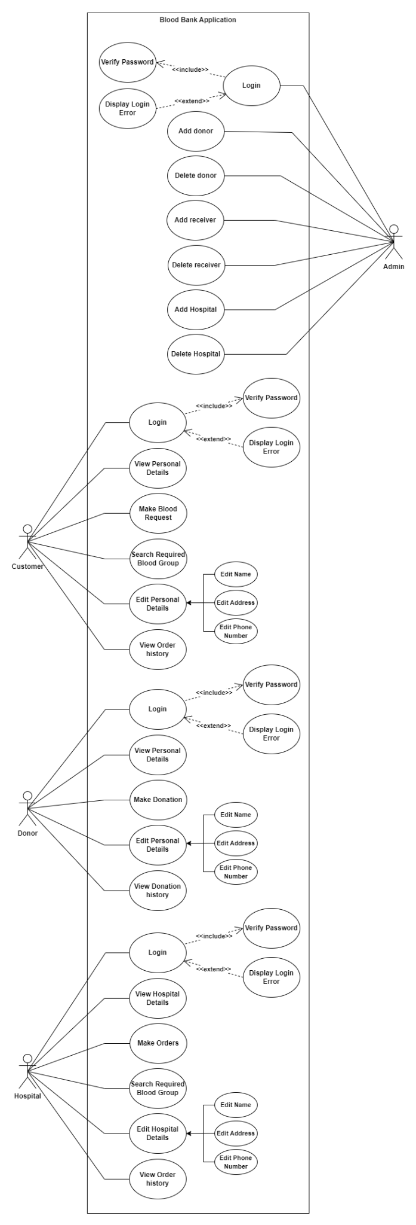

* 1. **ER diagram**

ER diagram represents the attributes of each entity to define the state of the entity and the relation between different entities.

1. **Project revision history:**

| **Date** | **Version** | **Author** | **Brief description of changes** |
| --- | --- | --- | --- |
| 22/09/2022 | 1.0 | Group1 | System Requirement Study (SRS) |
| 23/09/2022 | 1.0 | Group1 | Documentation part |
| 24/09/2022 | 1.0 | Group1 | ER diagram |
| 25/09/2022 | 1.0 | Group1 | Class diagram |
| 26/09/2022 | 1.0 | Group1 | Use case diagram |
| 28/09/2022 | 1.0 | Group1 | Activity diagram |
| 29/09/2022 | 1.0 | Group1 | Validations implementation |
| 30/09/2022 | 1.0 | Group1 | Deciding the test cases |
| 01/10/2022 | 1.0 | Group1 | Working on modules |
| 02/10/2022 | 1.0 | Group1 | Working on modules |
| 03/10/2022 | 1.0 | Group1 | Working on modules |
| 04/10/2022 | 1.0 | Group1 | Working on modules |
| 05/10/2022 | 1.0 | Group1 | Integration of all modules |
| 06/10/2022 | 1.0 | Group1 | Implementing the unit test cases |
| 07/10/2022 | 1.1 | Group1 | Making necessary modifications |